# Exercise 11: React Component

Objectives and Outcomes

A React component is a reusable building block in React, a popular JavaScript library for building user interfaces. React components are the fundamental units of a React application and are responsible for encapsulating UI logic and rendering elements on the screen. By the end of this exercise, you should have a good understanding of React components and how to create and use them in your applications.

Exercises

1. Create a to-do list application with add and delete functionality.

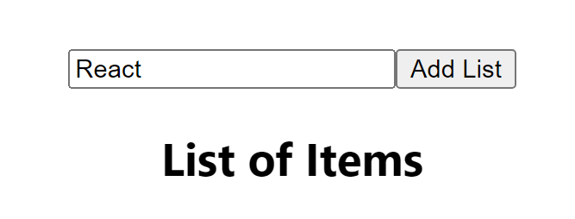

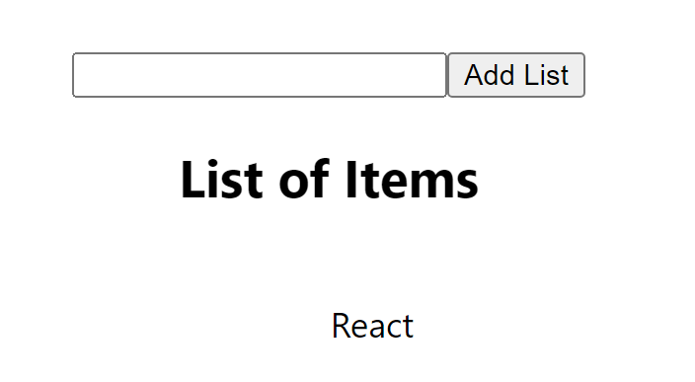

1. 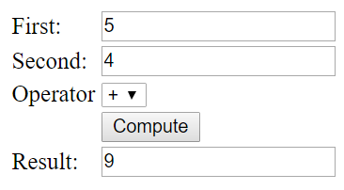Create a calculator that can perform basic arithmetic operations (addition, subtraction, multiplication, and division) .

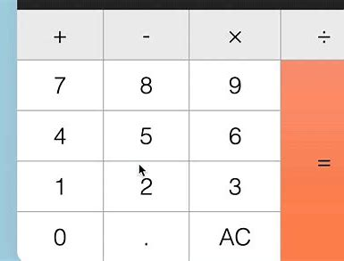

1. Build Search filter in React

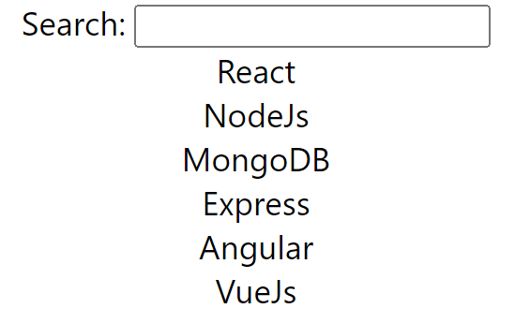

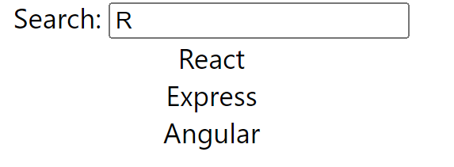

**Hint:**

* Declare React component states for search input values.
* Create HTML input text for entering search term and update state in onChange function.
* Add Array.filter() on list of items with search term value.

Conclusion

After learning about React components, you should now have a solid understanding of how to create and use them in your React applications.